**How to setup and configure babbles.co website**

**Setup babbles.co website following these steps:**

1. Setup apache server
2. Setup mod perl
3. Setup railo
4. Create babbles.co website
5. Url rewrite and case sensitive bugs fixed
6. Add my sql datasource
7. Access to available html page
8. **Setup apache server**

To install apache do the following command

sudo apt-get install apache2

1. **Setup mod perl for apache**

Apache needs to enable mod_perl to connect with tomcat/railo. To install do the following the command:

sudo apt-get install libapache2-mod-perl2

1. **Setup railo**

* Download latest railo on server for linux

<http://www.getrailo.org/index.cfm/download/>

* Install railo with Apache connection option

1. **Create babbles.co website**

* Add tomcat site

Modify tomcat *“/opt/railo/tomcat/conf/server.xml”* file

<Host name="babbles.com.vn" appBase="webapps">

<Context path="" docBase="/babbles.co/babbles.co" />

</Host>

* Add apache site

Add file “*babbles.com.vn.conf*” to folder “*/etc/apache2/sites-enabled*”

* Restart railo and apache server

Railo:

sudo service railo_ctl restart

Apache:

sudo service apache2 restart

1. **Url rewrite and case sensitive bugs fixed**

* Enable mod rewrite

sudo a2enmod rewrite

* Copy .htaccess to root folder with following content:

<IfModule mod_rewrite.c>

# try enabling symbolic links, some servers require it, depends on how the server is configured

Options +FollowSymLinks

RewriteEngine On

RewriteCond %{REQUEST_FILENAME} !-f

RewriteCond %{REQUEST_URI} /$ [NC]

RewriteRule ^/?(.*)$ $1index.cfm [PT,L]

RewriteCond %{REQUEST_FILENAME} !-f

RewriteCond %{REQUEST_URI} !\.(gif|jpg|jpeg|png|css|js|html)$ [NC]

RewriteRule ^/?(.*)$ $1.cfm [PT,L]

</IfModule>

* Support case sensitive for apache

Modify file “/etc/apache2/apache2.conf” change default proxy configuration to below

<IfModule mod_proxy.c>

<Proxy *>

Allow from 127.0.0.1

</Proxy>

ProxyPreserveHost On

ProxyPassMatch ^/(.+\.cf[cm])(/.*)?$ ajp://127.0.0.1:8009/$1$2

ProxyPassMatch ^/(.+\.cfchart)(/.*)?$ ajp://127.0.0.1:8009/$1$2

ProxyPassMatch ^/(.+\.cfml)(/.*)?$ ajp://127.0.0.1:8009/$1$2

ProxyPassMatch ^/(.+\.gif)(/.*)?$ ajp://127.0.0.1:8009/$1$2

ProxyPassMatch ^/(.+\.jpg)(/.*)?$ ajp://127.0.0.1:8009/$1$2

ProxyPassMatch ^/(.+\.jpeg)(/.*)?$ ajp://127.0.0.1:8009/$1$2

ProxyPassMatch ^/(.+\.png)(/.*)?$ ajp://127.0.0.1:8009/$1$2

ProxyPassMatch ^/(.+\.css)(/.*)?$ ajp://127.0.0.1:8009/$1$2

ProxyPassMatch ^/(.+\.js)(/.*)?$ ajp://127.0.0.1:8009/$1$2

ProxyPassMatch ^/(.+\.html)(/.*)?$ ajp://127.0.0.1:8009/$1$2

</IfModule>

* Add “web.xml” file to “WEB-INF” in current website folder

1. **Add my sql datasource**

Access to <http://127.0.0.1/railo-context/admin/server.cfm>

Add mysql datasource

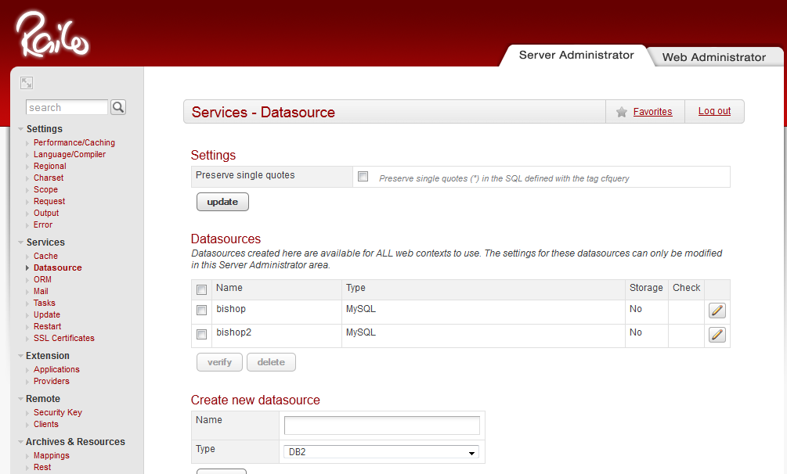

1. **Access to available html page**

Home page:

Community page: